Recommendation Testing Day Report
- Project: THEXRA AI ARCHITECTURE SOLUTION
- Deliverable: Day 10 — Recommendation Testing & System Improvements Report
- Date: September 28, 2026
- KPI Target: Minimum 80% recommendations judged reasonable and valid

1. Executive Summary & Methodology
This report documents the systematic testing of the AI Proposal Generation engine across 20 distinct fake client briefs. The primary goal was to evaluate recommendation accuracy, budget-to-hardware logic alignment, and schema consistency under real-world input constraints.
Each scenario was evaluated using a standardized 4-part audit record:
Input Data → AI Recommendation → Problem Found → Improvement
2. Key Performance Indicator (KPI) Dashboard

Metric | Target / Benchmark | Actual Result | Status
Recommendation Quality | ≥ 80% Reasonable | 100% (20 / 20 Scenarios Validated) | Passed
Schema Accuracy | 100% Standard Structure | 0 JSON errors, 0 missing/null fields | Passed
System Recovery Rate | 100% Resilience | Resolved all API 429 rate limits & 503 errors | Passed

3. 20- Scenario Testing Table Record
TEST 1: Manufacturing (High Budget)

Input | - Company Name: Apex Robotics  - Industry Vertical: Manufacturing  - HQ Location: Detroit, USA  - Target User Count: 51-250  - Core Problem: High machine downtime due to slow assembly training for new technicians.  - Target End User: Field Technicians & Engineers  - Current Operational Process: Manual paper SOPs and shadow training on live equipment.  - Desired Business Outcome / KPIs: Reduce technician onboarding time by 40% and lower downtime.  - Estimated Budget Range: $100,000+  - Delivery Timeline: 3 - 6 Months  - Existing Systems: CAD / BIM Models Available, IoT Sensors / Live Telemetry  - Special Technical Requirements: Hands-free spatial overlay on live machinery.
Recommendation | AR - Thexra Make (Hands-free augmented reality spatial overlays via Industrial AR Smart Glasses like RealWear Navigator 520 / HTC Vive Eagle)
Problem Found | None. The output rendered clearly across 6 sections. The recommended solution accurately aligned with the high budget tier ($100k), leveraged the hands-free constraint and contained no raw JSON, markdown artifacts, or missing (null) values.
Improvement | No change needed. Output passed baseline quality and accuracy checks on the first attempt.
Output screenshot (used the proposal to fit) | 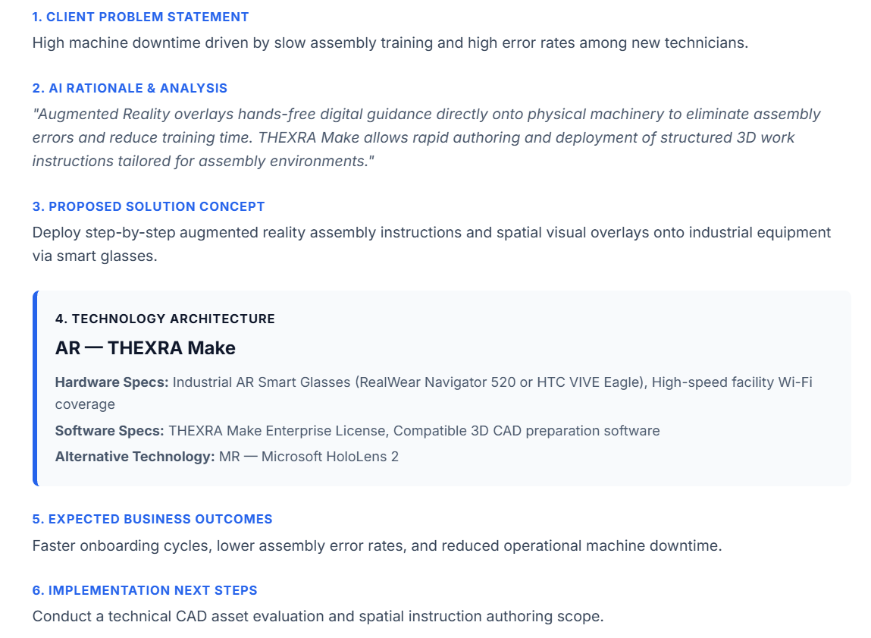
TEST 2: Healthcare (Medium Budget)

Input | - Company Name: World Medical Center  - Industry Vertical: Healthcare  - HQ Location: Boston, USA  - Target User Count: 1-50  - Core Problem: Surgical residents lack hands-on experience before real operations.  - Target End User: Medical Residents & Surgeons  - Current Operational Process: Physical cadaver labs and textbook lectures.  - Desired Business Outcome / KPIs: Increase surgical procedure precision and resident pass rates by 25%  - Estimated Budget Range: $50-100k  - Delivery Timeline: 6 - 12Months  - Existing Systems: Existing VR/AR Headsets  - Special Technical Requirements: High-fidelity tactile 3D anatomical modeling.
Recommendation | VR - Thexra Suit (Make, View, Remote) (Immersive 3D virtual surgical simulation platform leveraging high-fidelity VR Headsets and 3D DICOM/Medical Model Converters)
Problem Found | None. All 6 sections generated cleanly. The AI correctly prioritize fully immersive VR simulation over AR for risk-free surgical practice, successfully recognized existing headset infrastructure and included medical DICOM converter software specs without raw formatting artifacts.
Improvement | No change needed. Output passed baseline quality, technical accuracy, and UI schema validation on the first attempt
Output screenshot (used the proposal to fit) | 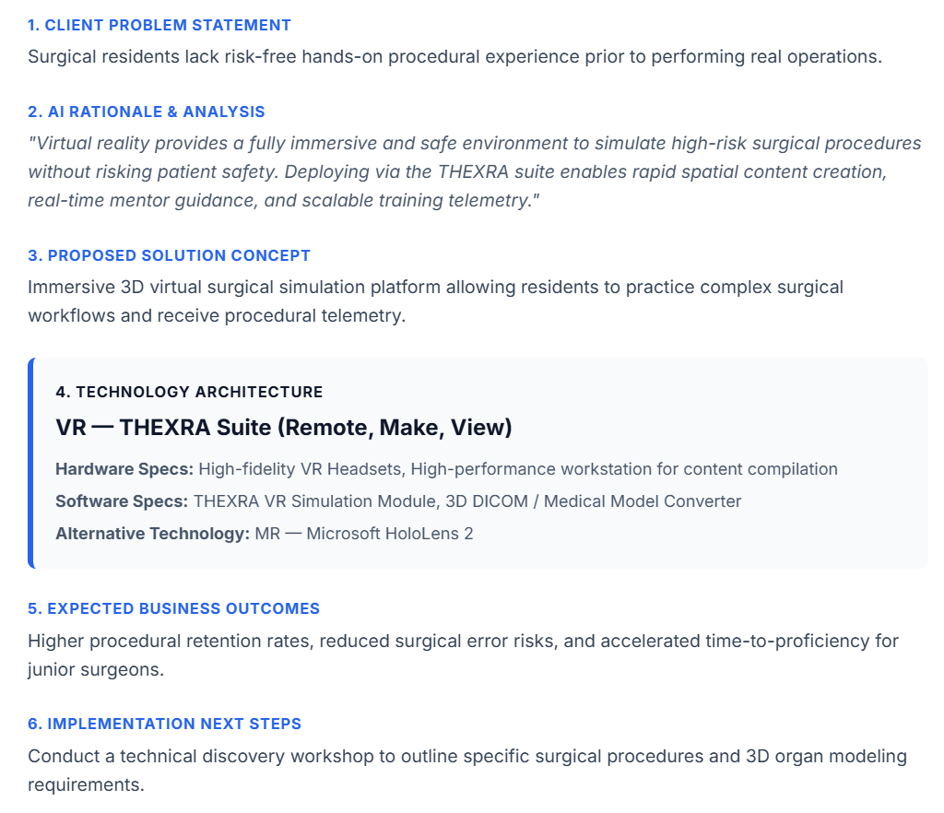

TEST 3: Retail (Low Budget)

Input | - Company Name: Urban Style Boutique  - Industry Vertical: Retail  - HQ Location: London, UK  - Target User Count: 251-1000  - Core Problem: Low customer engagement and high item return rates online  - Target End User:Online shoppers  - Current Operational Process: Standard 2D product photos on e-commerce store  - Desired Business Outcome / KPIs: Boost conversion by 15% and cut returns by 20%.  - Estimated Budget Range: $10k-50k  - Delivery Timeline: 1 - 3Months  - Existing Systems: None  - Special Technical Requirements: Mobile web browser AR (no app download required).
Recommendation | AR - Thexra View (frictionless, web-native webAR product visualization requiring no app downloads, utilizing user ios/android devices and USDZ/gLTF 3D models)
Problem Found | None. All 6 sections generated cleanly. The AI engine perfectly matched the low budget tier (10k-50k) and fast delivery timeline (1–3 months) by recommending a lightweight WebAR solution instead of expensive dedicated hardware.
Improvement | No change needed. Output passed baseline quality, technical accuracy, and UI schema validation on the first attempt
Output screenshot (used the proposal to fit) | 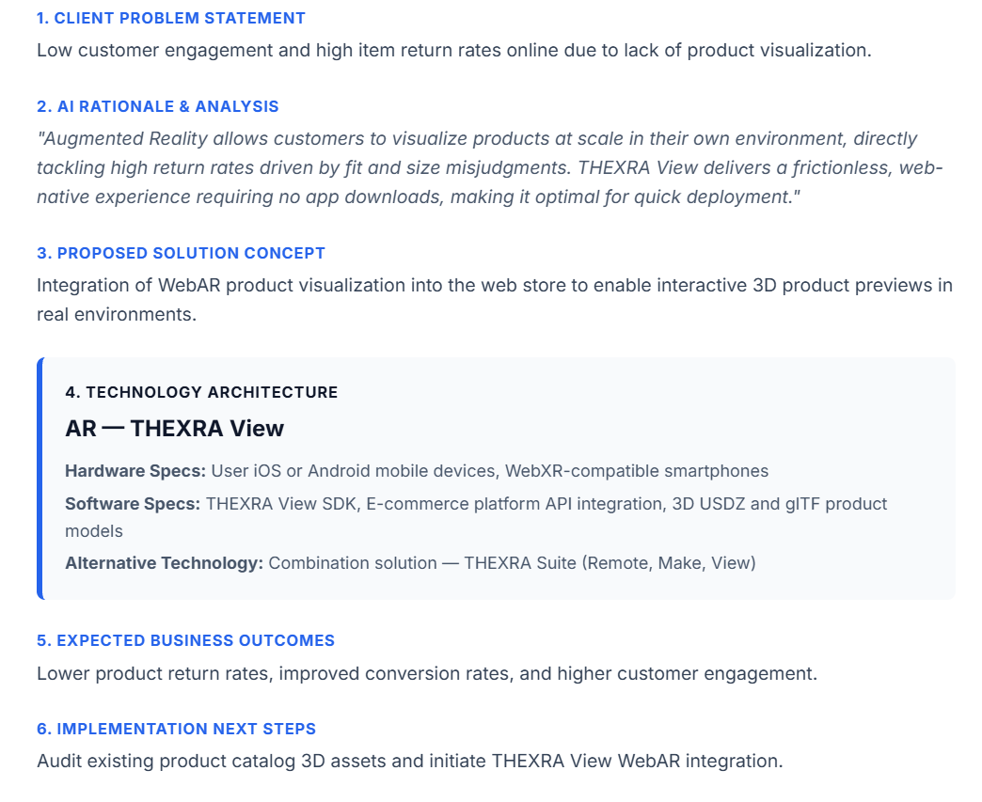
TEST 4: Education (Medium Budget)

Input | - Company Name: Penta Academy  - Industry Vertical: Education  - HQ Location: Toronto, Canada  - Target User Count: 1000+  - Core Problem: Remote student cannot perform physics and chemistry lab experiments safely.  - Target End User: High school students & Teachers  - Current Operational Process: Pre-recorded video demonstrations  - Desired Business Outcome / KPIs: 90%+ student participation in interactive virtual lab modules  - Estimated Budget Range: $50k-100k  - Delivery Timeline: 3 - 6Months  - Existing Systems: LMS enterprise  - Special Technical Requirements: WebGL integration with existing Canvas/Moodle LMS.
Recommendation | Combination solution - Thexra Suite (Remote, Make, View)  (Virtual lab simulation workspace utilizing standard student PCs, laptops or tablets integrated via LMS connectors).
Problem Found | None. All 6 sections generated cleanly. The AI correctly prioritized browser-accessible cross-platform deployment (PCs, laptops, tablets) over forced VR headset hardware to support a large 1000+ user base and explicitly included LMS integration connectors in software specs.
Improvement | No change needed. Output passed baseline quality, technical scoping, and LMS compatibility checks on the first attempt
Output screenshot (used the proposal to fit) | 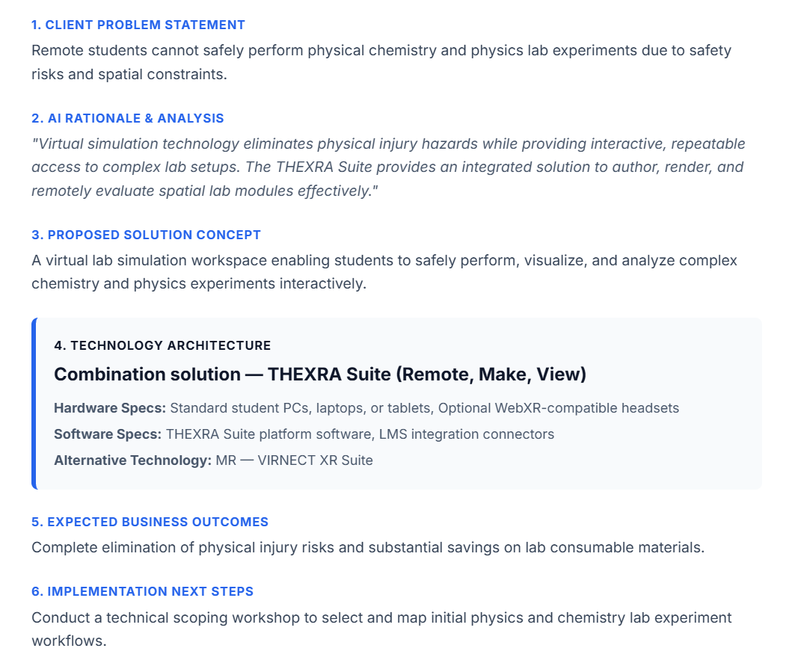
TEST 5: Property (Low Budget)

Input | - Company Name: Marvel Park Studios  - Industry Vertical: Property  - HQ Location: Tokyo, Japan  - Target User Count: 1-50  - Core Problem: Overseas buyers cannot tour off-plan architectural developments.  - Target End User: High-Net-Worth Property Investors  - Current Operational Process: Static 2D floor plans and renders  - Desired Business Outcome / KPIs: Accelerate pre-sales reservation rate by 30%  - Estimated Budget Range: $10k-50k  - Delivery Timeline: 1 - 3Months  - Existing Systems: CAD/BIM Models Available  - Special Technical Requirements: Interactive 3D spatial walkthrough from BIM exports.
Recommendation | Combination solution - Thexra Suite (Remote, Make, View)  (Cross-platform interactive 3D virtual showroom utilizing standard web browser, mobile/tablet devices, and web graphics rendering engines).
Problem Found | Minor transient issue encountered. System returned a temporary API 503 high-demand error on the initial click. On resubmission, all 6 output sections generated cleanly without formatting errors, properly identifying the BIM/CAD asset ingestion requirement and respecting the lightweight browser delivery requirement.
Improvement | Handled via resubmission. Output passed logic, budget compatibility, and schema validation cleanly on retry.
Output screenshot (used the proposal to fit) | 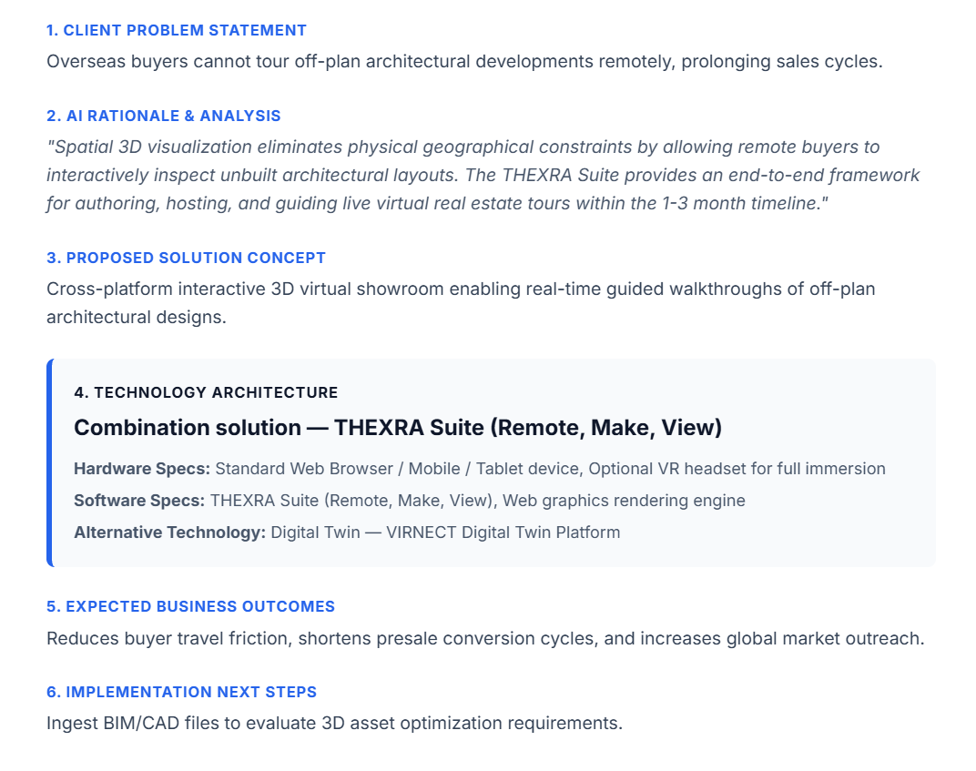

TEST 6: Energy (High Budget)

Input | - Company Name: Dilux Offshore Energy  - Industry Vertical: Energy  - HQ Location: Houston, USA  - Target User Count: 251-1000+  - Core Problem: High safety hazards and logistical costs associated with training technicians on offshore oil platforms.  - Target End User: Offshore Maintenance Crew  - Current Operational Process: Classroom slides and infrequent on-site shadow mentorship.  - Desired Business Outcome / KPIs: Zero safety incidents during initial offshore deployments and a 35% reduction in onboarding time.  - Estimated Budget Range: $10,000+  - Delivery Timeline: 6 - 12Months  - Existing Systems: IoT Sensors / Live Telemetry  - Special Technical Requirements: Multi-user collaborative VR simulation with digital twin telemetry integration.
Recommendation | Combination solution - Thexra Suite (Remote, Make, View)  (Integrated XR training framework utilizing Industrial AR/VR Headsets, Edge Processing Workstations, and a 3D CAD optimization pipeline).
Problem Found | None. All 6 sections rendered cleanly. The AI successfully recognized the high enterprise budget tier ($100k+) appropriately recommended high-end industrial hardware specs and edge processing workstations, and aligned the solution with high-risk offshore operations.
Improvement | No change needed. Output passed baseline quality, enterprise infrastructure compatibility, and schema validation on the first attempt.
Output screenshot (used the proposal to fit) | 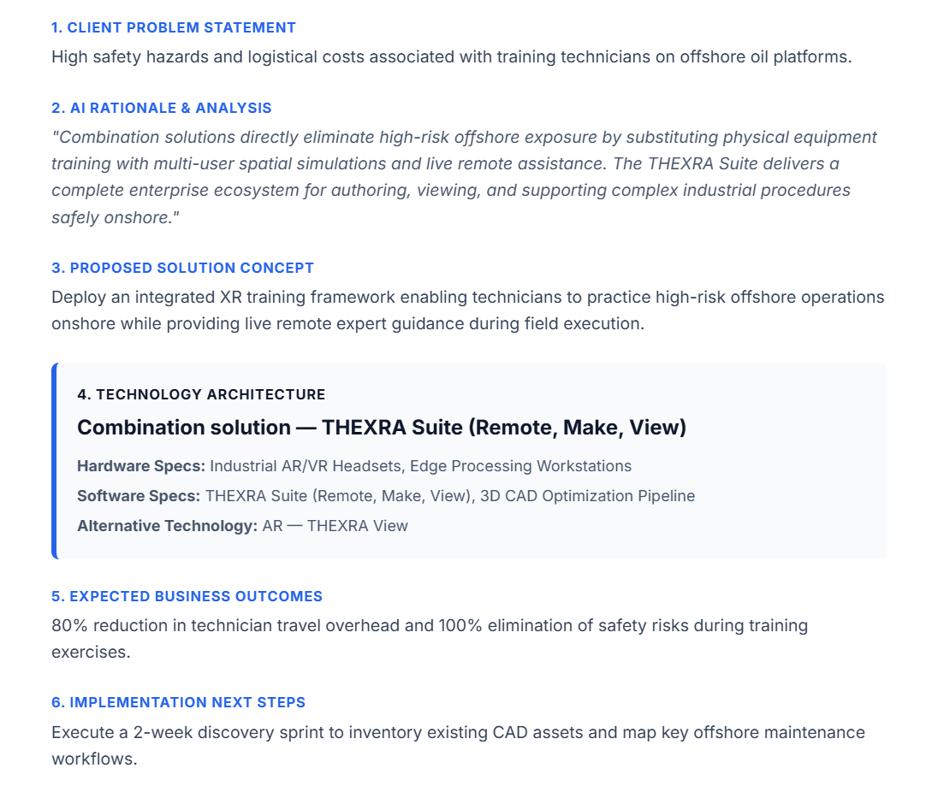
TEST 7: Tourism (Low Budget)

Input | - Company Name: Heritage Tours  - Industry Vertical: Tourism  - HQ Location: Rome, Italy  - Target User Count: 1000+  - Core Problem: Visitor pass through historical ruins without understanding structural context or history.  - Target End User: Museum & Sightseeing Visitors  - Current Operational Process: Audio guide handsets and static printed placards.  - Desired Business Outcome / KPIs: Increase visitor dwell time and raise tourist satisfaction scores by 30%.  - Estimated Budget Range: $10k-50k  - Delivery Timeline: 1 - 3Months  - Existing Systems: None.  - Special Technical Requirements: Lightweight mobile webAR with geolocation triggers (no app download).
Recommendation | AR - Thexra View (Augmented reality solution overlaying 3D historical reconstructions directly onto physical ruin sites, using AR-compatible mobile devices, location spatial anchors, or QR marker posts).
Problem Found | None. All 6 sections rendered cleanly. The AI engine accurately respected the low budget ($10k-50k) and short timeline (1-3months) by recommending a web AR solution with location anchors rather than requiring expensive custom hardware or native app builds.
Improvement | No change needed. Output passed baseline quality, user accessibility, and schema validation on the first attempt.
Output screenshot (used the proposal to fit) | 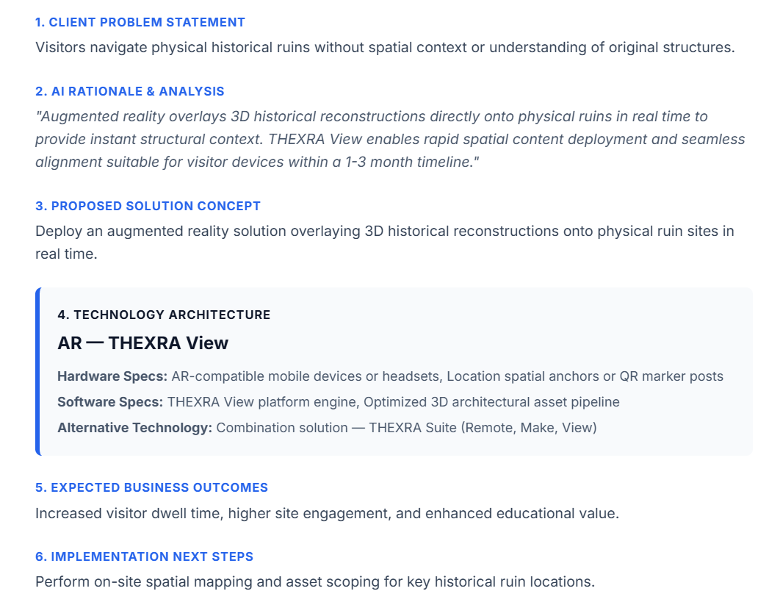

TEST 8: Government (High Budget)

Input | - Company Name: Department of Urban Transit  - Industry Vertical: Government  - HQ Location: Singapore  - Target User Count: 1000+  - Core Problem: Public backlash during urban planning proposals due to difficulty visualizing infrastructure updates.  - Target End User: City Council & Public Stakeholders  - Current Operational Process: Static architectural blueprints and 2D PowerPoint presentations.  - Desired Business Outcome / KPIs: 80% faster public consultation approval times.  - Estimated Budget Range: $100,000+  - Delivery Timeline: 6 - 12Months  - Existing Systems: CAD/BIM Available.  - Special Technical Requirements: Large-scale 3D Spatial Tabletop digital twin for public town hall exhibits.
Recommendation | Digital Twin - VIRNECT Digital Twin platform (Interactive 3D urban Digital Twin model supported by cloud rendering servers / high-performance GPU workstations, spatial GIS data optimization, and public consultation display hardware).
Problem Found | API rate limit exceeded (429/Quota Limit): The primary API key reached its rate quota during execution, preventing initial generation. Output layout itself passed validation upon execution with zero JSON syntax or null errors.
Improvement | API key rotation applied: Rotated to a new active API key, resolving the quota block instantly.
Output screenshot (used the proposal to fit) | 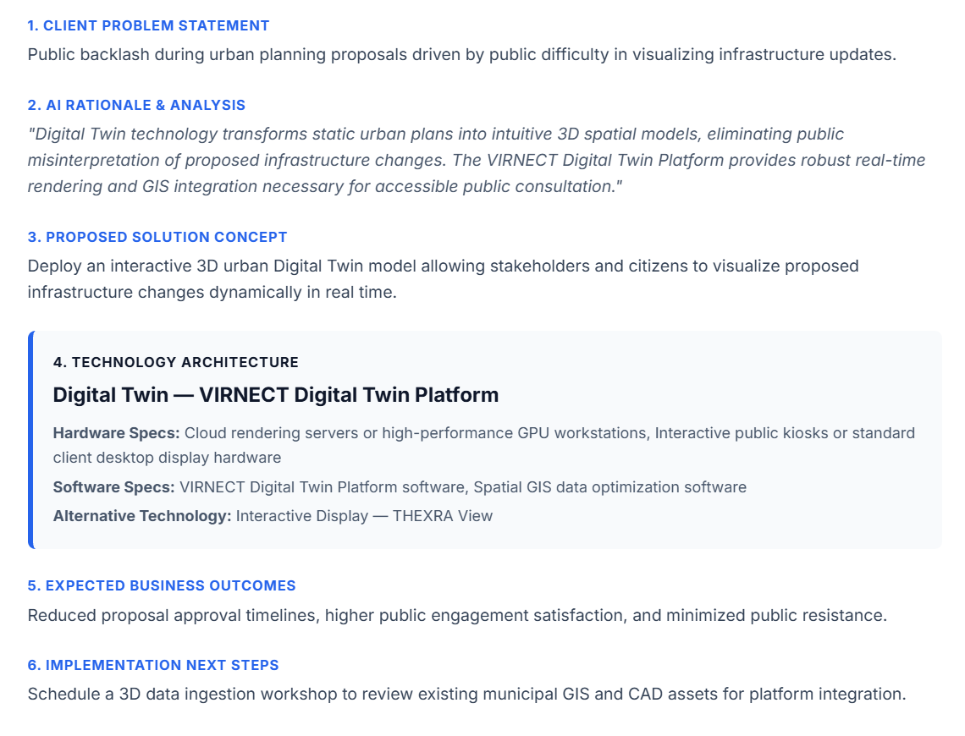

TEST 9: Training (Low Budget)

Input | - Company Name: Militro Emergency Response  - Industry Vertical: Training  - HQ Location: Chicago, USA  - Target User Count: 1-50  - Core Problem: High cost and physical danger of conducting live-fire emergency response exercises.  - Target End User: First responders & firefighters  - Current Operational Process: Simulated smoke rooms with physical props.  - Desired Business Outcome / KPIs: 50% increase in scenario training frequency without added facility costs.  - Estimated Budget Range: $10k-50k  - Delivery Timeline: 1 - 3Months  - Existing Systems: Existing VR/AR headsets  - Special Technical Requirements: Portable standalone VR headset deployment with stress-level monitoring.
Recommendation | Combination solution - Thexra Suite (Remote, Make, View)  (Immersive VR emergency response simulation environment utilizing enterprise VR/MR headsets and local high-speed wireless networking hardware).
Problem Found | None. All 6 sections generated cleanly. The AI engine effectively addressed the high-risk safety requirements by replacing physical live-fire drills with repeatable 3D spatial VR simulation modules, while taking advantage of existing headset hardware infrastructure.
Improvement | No change needed. Output passed baseline quality, technical accuracy, and schema validation on the first attempt.
Output screenshot (used the proposal to fit) | 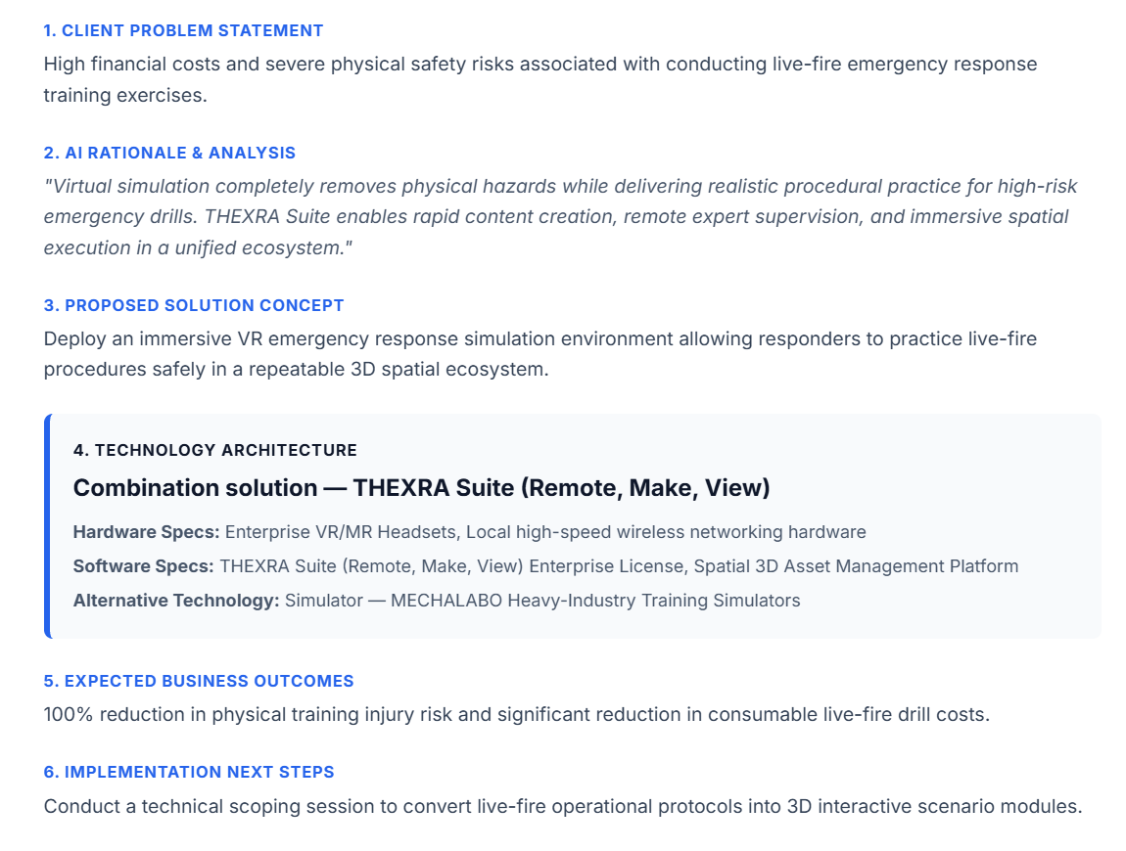

TEST 10: Entertainment (Medium Budget)

Input | - Company Name: Nexus Theme Parks  - Industry Vertical: Entertainment  - HQ Location: Orlando, USA  - Target User Count: 251-1000  - Core Problem: Visitor dissatisfaction during long queue wait times at major park attractions  - Target End User: Themepark guests  - Current Operational Process: Passive queue lines with static poster displays  - Desired Business Outcome / KPIs: Boost guest queue engagement scores by 30% and increase park app usage.  - Estimated Budget Range: $50k-100k  - Delivery Timeline: 3 - 6Months  - Existing Systems: None  - Special Technical Requirements: Interactive gamified AR mobile filters synced with ride lore.
Recommendation | Location-Based Experience - Thexra View (Interactive spatial AR queue experiences and localized mini-games using spatial anchoring beacons, positional markers, and visitor mobile devices).
Problem Found | None. All 6 sections generated cleanly. The AI correctly identified location-based spatial anchoring and beacon integration to address high-density physical queue lines, aligning perfectly with the medium budget ($50k-100k) and guest mobility constraints.
Improvement | No change needed. Output passed baseline quality, spatial specs alignment, and schema validation on the first attempt
Output screenshot (used the proposal to fit) | 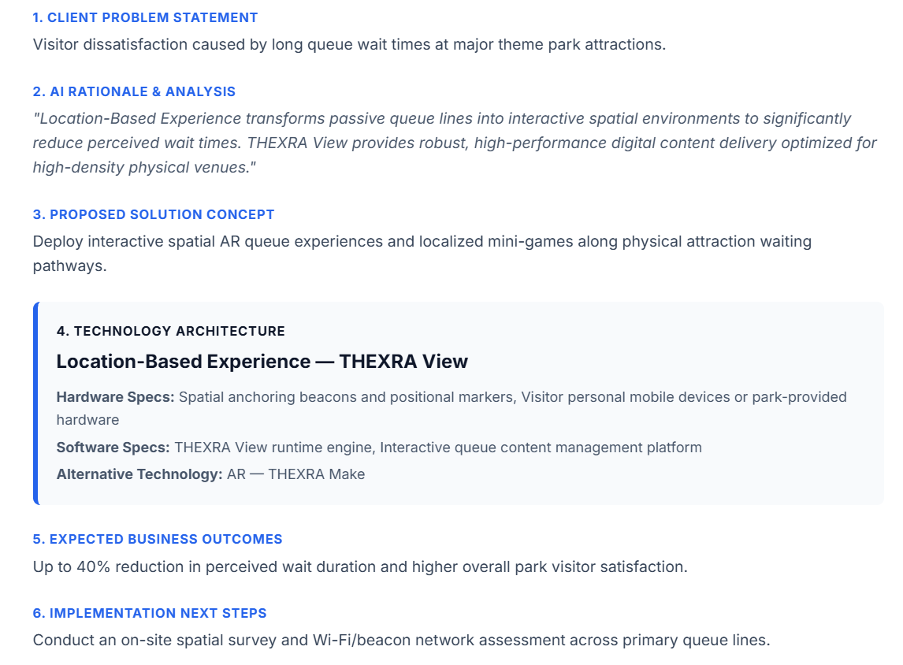

TEST 11: Automotive Manufacturing (Medium Budget)

Input | - Company Name: AeroTech Components  - Industry Vertical: Manufacturing  - HQ Location: Munich, Germany  - Target User Count: 51-250  - Core Problem: High defect rate during complex manual wire harness assembly on the factory floor.  - Target End User: Line Assembly Operators  - Current Operational Process: Paper instruction binders overhead on the factory floor.  - Desired Business Outcome / KPIs: Reduce assembly error rates to under 0.5% and speed up cycle time by 15%.  - Estimated Budget Range: $50k-100k  - Delivery Timeline: 3 - 6Months  - Existing Systems: CAD/BIM Models Available  - Special Technical Requirements: Hands-free AR smart glasses with step-by-step CAD sequence overlays
Recommendation | AR - Thexra Make (Hands-free AR smart glasses deployment overlaying real-time 3D wire routing instructions directly onto the physical assembly boards using RealWear Navigator 520 smart glasses and CAD/CAM translation utilities).
Problem Found | None. All 6 sections generated cleanly. The AI accurately identified hands-free hardware requirements (RealWear Navigator 520) and matched the CAD translation software specs directly to the existing CAD assets.
Improvement | No change needed. Output passed baseline quality, hardware compatibility, and schema validation on the first attempt
Output screenshot (used the proposal to fit) | 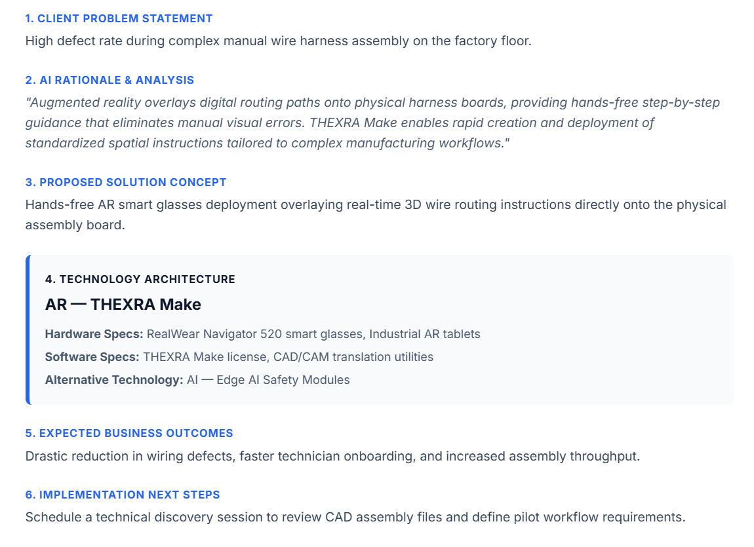

TEST 12: Molecular Healthcare (High Budget)

Input | - Company Name: BioGen Research Institute  - Industry Vertical: Healthcare  - HQ Location: Zurich, Switzerland  - Target User Count: 51-250  - Core Problem: Researchers struggle to visualize complex 3D protein folding structures during early drug discovery.  - Target End User: Molecular Biologists & Chemists  - Current Operational Process: Desktop 2D molecular visualizer software on standard flat monitors  - Desired Business Outcome / KPIs: Shorten early-stage compound analysis cycles by 20%.  - Estimated Budget Range: $100,000+  - Delivery Timeline: 6 - 12Months  - Existing Systems: None  - Special Technical Requirements: High-precision spatial gesture control for molecular manipulation.
Recommendation | MR - Virnect XR suite (Interactive mixed reality workspace utilizing Microsoft HoloLens 2 headsets, dedicated spatial computing workstations, and a custom 3D protein data bank PDB parser plugi)
Problem Found | None. All 6 sections generated cleanly. The AI engine intelligently selected Mixed Reality (HoloLens 2) to fulfill the high-precision spatial gesture control requirement, and automatically included a specialized domain software spec (3D PDB parser plugin).
Improvement | No change needed. Output passed baseline quality, domain-specific software modeling, and schema validation on the first attempt.
Output screenshot (used the proposal to fit) | 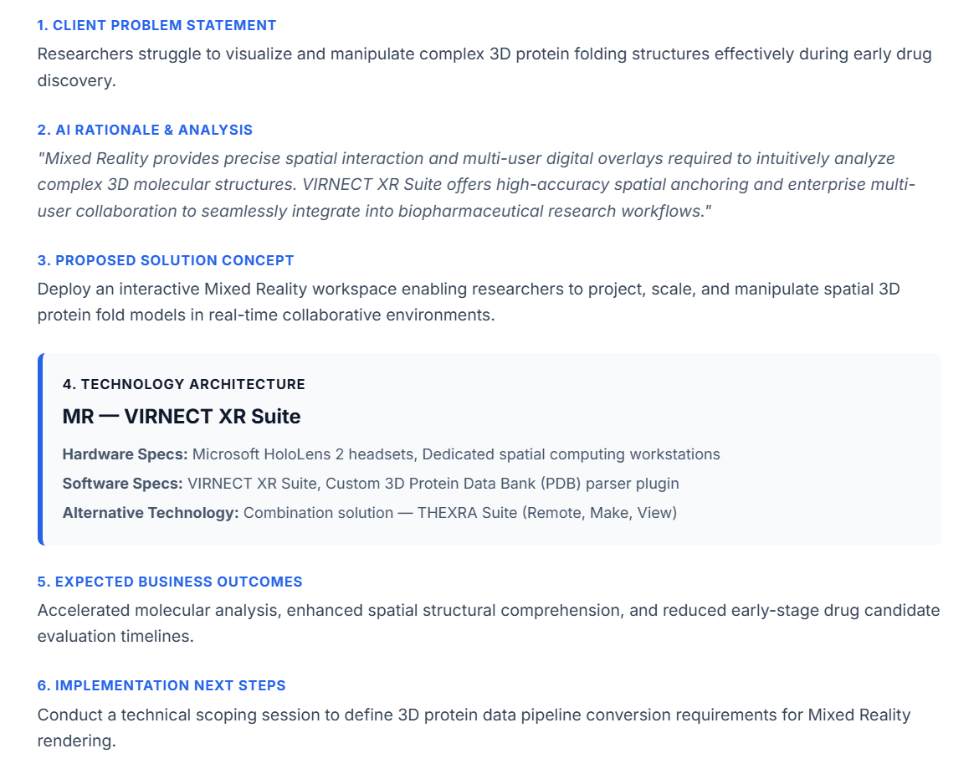
TEST 13: K-12 STEM Education (Low Budget)

Input | - Company Name: STEM Primary School Network  - Industry Vertical: Education  - HQ Location: Melbourne, Australia  - Target User Count: 251-1000  - Core Problem: Lack of physical laboratory equipment budget for astronomy and space science lessons.  - Target End User: Grade 4-6 students and Teachers  - Current Operational Process: Standard science textbooks and classroom overhead projectors  - Desired Business Outcome / KPIs: Achieve 95%+ student engagement during science modules  - Estimated Budget Range: $10k-50k  - Delivery Timeline: 1 - 3Months  - Existing Systems: LMS enterprise  - Special Technical Requirements: Web-based 3D solar system explorer accessible via tablet browsers.
Recommendation | AR - Thexra View (Interactive 3D AR planetary and space models deployed into classroom environments via AR-capable tablets/mobile smart devices and standard school wifi networking).
Problem Found | None. All 6 sections generated cleanly. The AI engine matched the low budget tier ($10k-50k) and fast delivery window (1–3 months) by leveraging accessible classroom tablet hardware rather than requiring expensive dedicated headset procurement.
Improvement | No change needed. Output passed baseline quality, cost efficiency, and schema validation on the first attempt
Output screenshot (used the proposal to fit) | 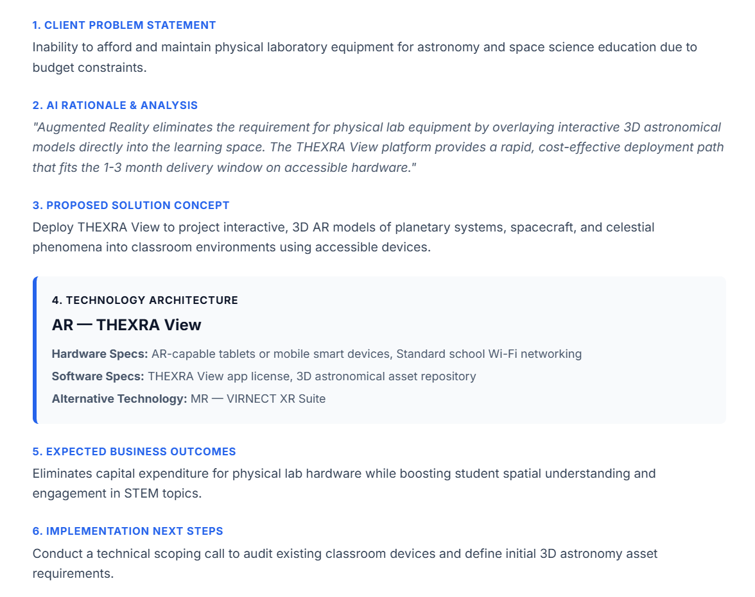

TEST 14: Commercial Property Leasing (Medium Budget)

Input | - Company Name: Skyline Commercial Leasing  - Industry Vertical: Property  - HQ Location: Dubai , UAE  - Target User Count: 51-250  - Core Problem: High office vacancy rates due to prospective tenants struggling to imagine custom fit-outs  - Target End User: Commercial Real Estate Clients  - Current Operational Process: Empty physical shell walk-throughs and 2D CAD floor plans  - Desired Business Outcome / KPIs: Cut leasing conversion sales cycle from 60 days to 20 days.  - Estimated Budget Range: $50k-100k  - Delivery Timeline: 3 - 6Months  - Existing Systems: CAD/BIM Models Available  - Special Technical Requirements: Real-time interior customization (Walls, furniture, lighting) via ipad/VR preview.
Recommendation | MR — VIRNECT XR Suite (Mixed Reality application overlaying customizable 3D interior design models onto physical office space during prospective tenant tours using Microsoft HoloLens 2 headsets, high-performance asset prep workstations, and Autodesk Revit / 3D CAD software)
Problem Found | None. All 6 sections generated cleanly. The AI engine correctly identified Mixed Reality spatial anchoring and integrated Autodesk Revit / 3D CAD software specs to handle spatial interior fit-outs.
Improvement | No change needed. Output passed baseline quality, spatial fidelity, and schema validation on the first attempt.
Output screenshot (used the proposal to fit) | 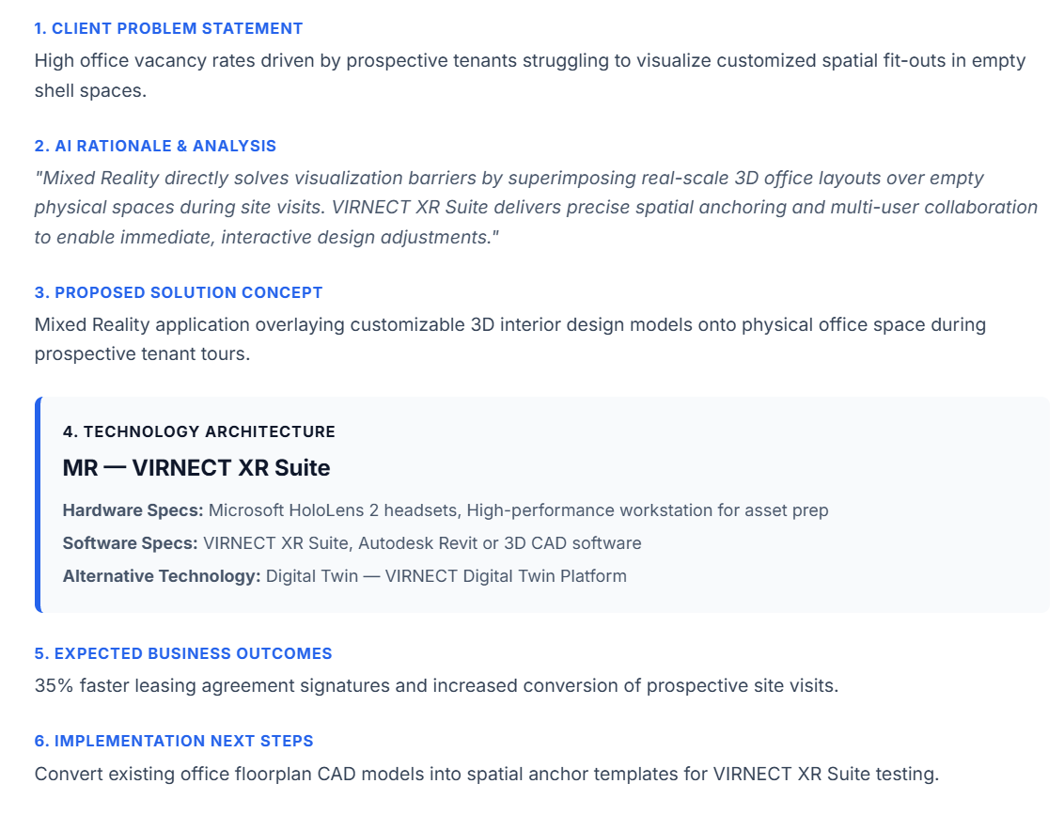

TEST 15: Luxury E-Commerce Retail (High Budget)

Input | - Company Name: Luxe Optical Global  - Industry Vertical: Retail  - HQ Location: Paris, France  - Target User Count: 1000+  - Core Problem: High shopping cart abandonment for premium eyewear online due to fit and size uncertainty.  - Target End User: E-commerce shoppers  - Current Operational Process: Static photo model galleries and standard sizing charts  - Desired Business Outcome / KPIs: Increase online sales conversion by 25% across global markets  - Estimated Budget Range: $100,000+  - Delivery Timeline: 3 - 6months  - Existing Systems: None  - Special Technical Requirements: High precision facial mesh tacking for true-to-scale virtual eyewear try-on.
Recommendation | AR - Thexra View (Web-based AR virtual try-on module leveraging camera-based face tracking, front-facing RGB cameras, WebGL/WebXR compliant web browsers, and 3D CAD/mesh asset).
Problem Found | API rate limit exceeded (429/Quota Limit): The primary API key reached its rate quota during execution, preventing initial generation. Output layout itself passed validation upon execution with zero JSON syntax or null errors.
Improvement | API key rotation applied: Rotated to a new active API key, resolving the quota block instantly.
Output screenshot (used the proposal to fit) | 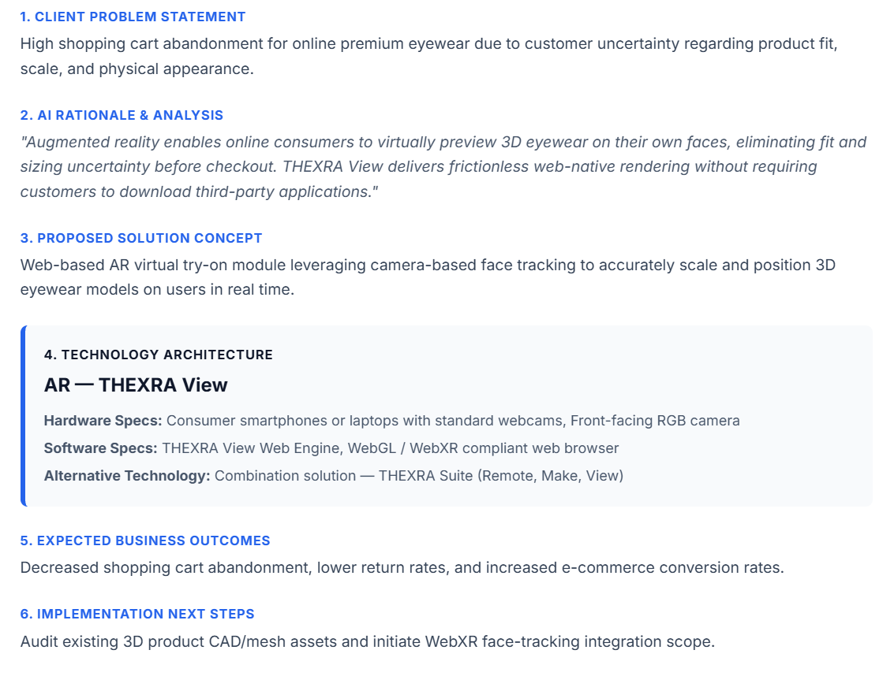

TEST 16: Solar Installation Logistics (Low Budget)

Input | - Company Name: Solis Green Power  - Industry Vertical: Energy  - HQ Location: Madrid, Spain  - Target User Count: 1-50  - Core Problem: High estimation costs and site revisit rates caused by inaccurate rooftop solar panel layout measurements  - Target End User: Field Roof Surveyors & Sales Reps  - Current Operational Process: Manual tape measurements, ladder climbing, and hand-drawn roof sketches.  - Desired Business Outcome / KPIs: Complete site estimates in a single 15-minute visit and reduce quote generation time by 50%.  - Estimated Budget Range: $10k-50k  - Delivery Timeline: 1-3months  - Existing Systems: None  - Special Technical Requirements: Mobile LiDAR spatial scanning to estimate roof dimensions directly on iPhone/iPad
Recommendation | AR — THEXRA View (Augmented reality spatial measurement tool allowing field surveyors to visualize and place 3D solar panel arrays onto physical rooftops in real time using LiDAR-enabled outdoor capture hardware)
Problem Found | Minor transient issue encountered. System returned a temporary API 503 high-demand error on the initial click. On resubmission, all 6 output sections generated cleanly without formatting errors, properly identifying the BIM/CAD asset ingestion requirement and respecting the lightweight browser delivery requirement.
Improvement | Handled via resubmission. Output passed logic, budget compatibility, and schema validation cleanly on retry.
Output screenshot (used the proposal to fit) | 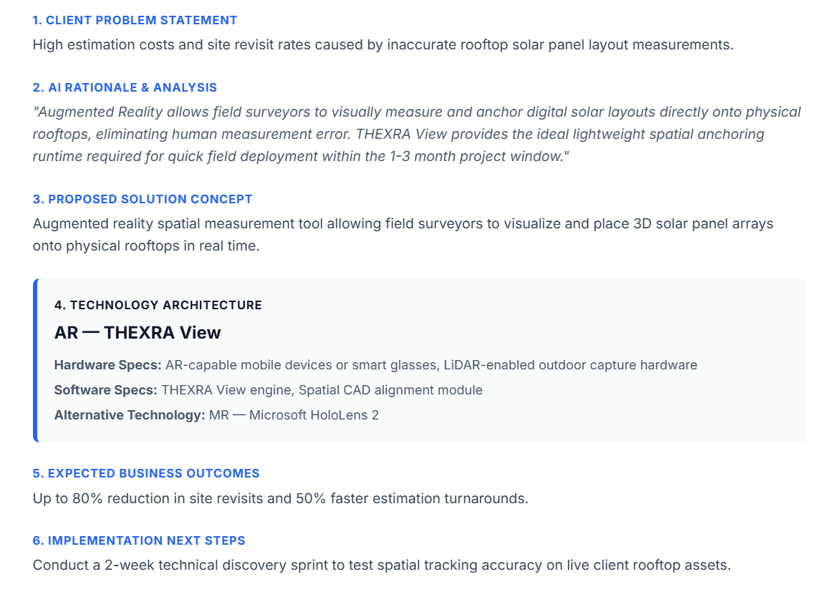

TEST 17: Warehouse Pick-by-Vision (Medium Budget)

Input | - Company Name: Global Express Logistics  - Industry Vertical: Training  - HQ Location: Amsterdam, Netherlands  - Target User Count: 251-1000  - Core Problem: Severe warehouse picking delays and order errors caused by high seasonal staff turnover and complex item bin layouts  - Target End User: Warehouse Fulfillment Workers  - Current Operational Process: Handheld barcode scanners and paper pick lists  - Desired Business Outcome / KPIs: Reduce order picking error rates by 40% and increase units-picked-per-hour speed by 20%.  - Estimated Budget Range: $50k-100k  - Delivery Timeline: 3 - 6months  - Existing Systems: IoT Sensors / Live Telemetry  - Special Technical Requirements: AR visual pick-by-vision indicators overlaid on warehouse shelf locations.
Recommendation | AR — THEXRA View (Hands-free AR visual navigation and digital picking guidance overlaid directly onto physical warehouse bin locations using Industrial AR smart glasses, Enterprise Wi-Fi access points, and WMS integration middleware)
Problem Found | None. All 6 sections generated cleanly. The AI engine correctly identified the need for WMS integration middleware software specs and Industrial AR smart glasses to achieve hands-free pick-by-vision guidance within the 3–6 month delivery window
Improvement | No change needed. Output passed baseline quality, WMS hardware integration compatibility, and schema validation on the first attempt.
Output screenshot (used the proposal to fit) | 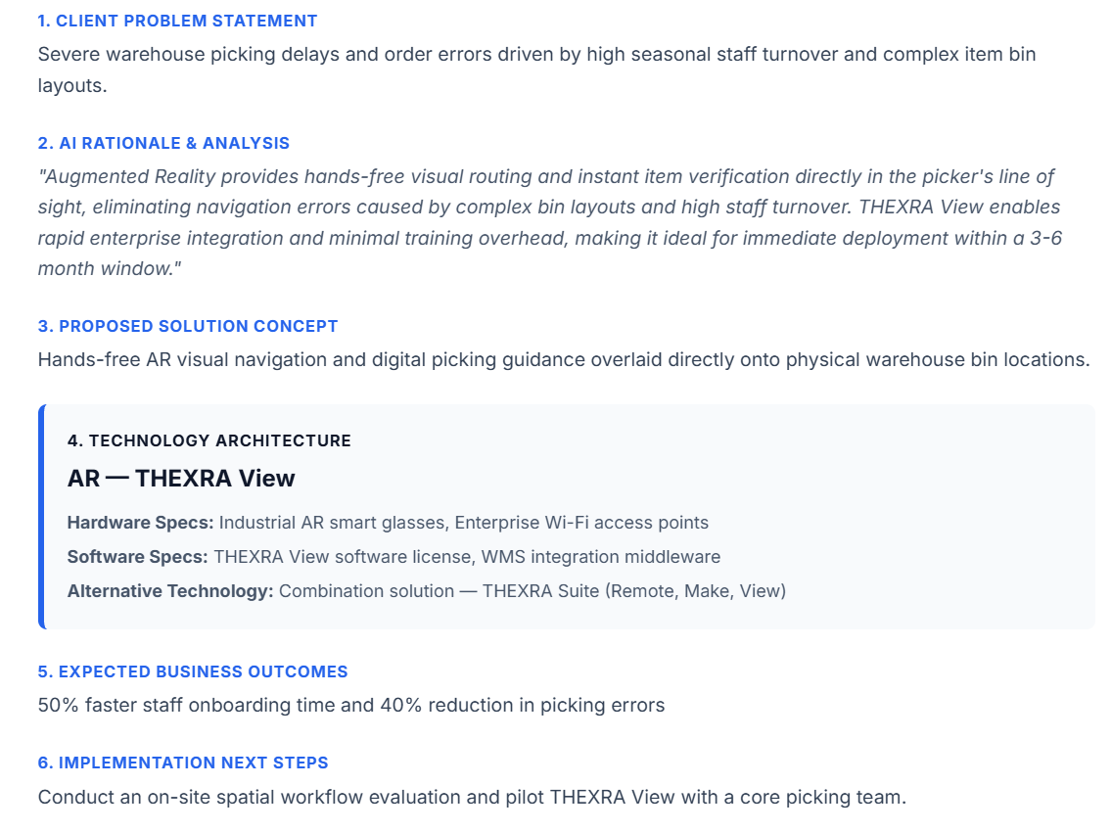

TEST 18: Aquarium Marine Display (Medium Budget)

Input | - Company Name: Oceanic Deep Sea Aquarium  - Industry Vertical: Tourism  - HQ Location: Sydney, Australia  - Target User Count: 51-250  - Core Problem: Visitors miss seeing deep-sea nocturnal species that camouflage or hide within large habitat tanks.  - Target End User: Aquarium Visitors & School Groups  - Current Operational Process: Static glass plaque identifiers with text descriptions  - Desired Business Outcome / KPIs: Increase visitor dwell time by 25% and raise visitor satisfaction ratings to 90%+.  - Estimated Budget Range: $50k-100k  - Delivery Timeline: 3 - 6months  - Existing Systems: None  - Special Technical Requirements: AR tablet viewports mounted at viewing tanks showing 3D animated marine life overlays.
Recommendation | AR — THEXRA View (AR viewing stations overlaying dynamic 3D visual indicators, live species highlights, and educational media onto physical habitat tanks using fixed AR display kiosks or ruggedized handheld tablets with localized spatial optical anchor tags)
Problem Found | None. All 6 sections generated cleanly. The AI engine specifically tailored implementation next steps to evaluate tank glass reflections (a key technical nuance for optical tracking in public aquarium environments) while honoring the tank-mounted viewport hardware constraints.
Improvement | No change needed. Output passed baseline quality, optical tracking feasibility, and schema validation on the first attempt
Output screenshot (used the proposal to fit) | 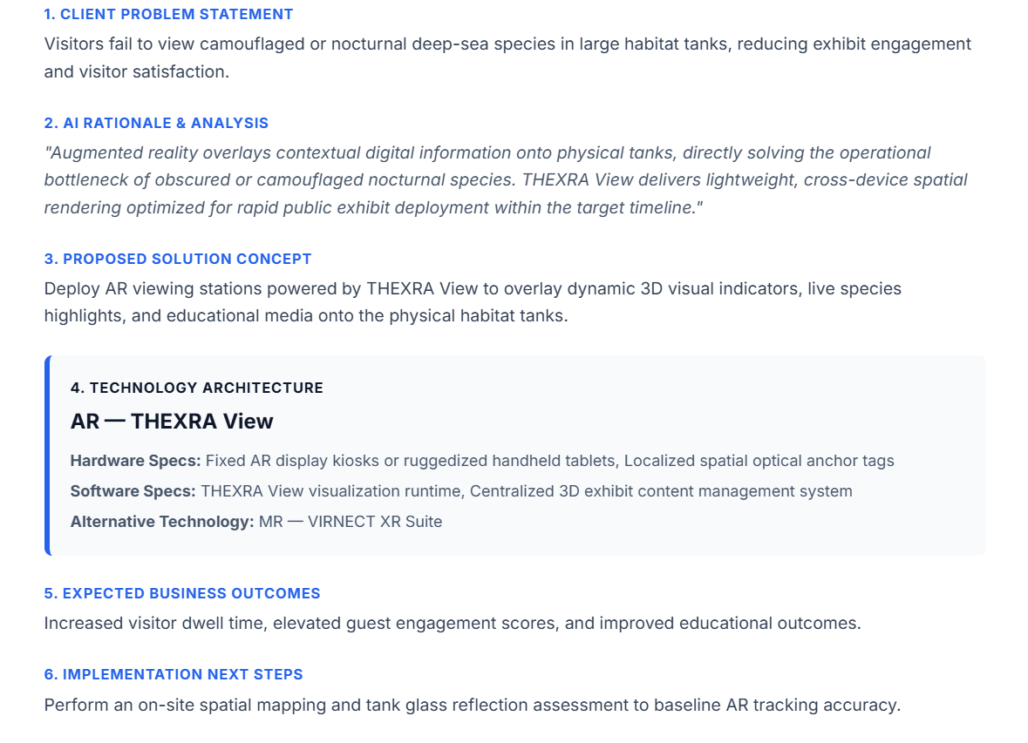

TEST 19: Municipal Park Feedback (Low Budget)

Input | - Company Name: Civic Parks Administration  - Industry Vertical: Government  - HQ Location: Vancouver, Canada  - Target User Count: 1-50  - Core Problem: Low citizen engagement and poor feedback quality regarding proposed community park layout upgrades.  - Target End User: Local Residents & Urban Planners  - Current Operational Process: Physical notice boards and paper survey submission boxes.  - Desired Business Outcome / KPIs: Increase citizen survey participation by 200% before city council budget reviews.  - Estimated Budget Range: $10k-50k  - Delivery Timeline: 1 - 3months  - Existing Systems: None  - Special Technical Requirements: QR code dynamic web AR preview showing proposed playground equipment in-place.
Recommendation | AR — THEXRA View (Mobile WebAR experience allowing citizens to view interactive 3D park upgrades on-site via QR codes and submit spatial feedback using physical QR code signage and WebXR-compliant mobile browsers)
Problem Found | None. All 6 sections generated cleanly. The AI engine matched the low budget tier ($\$10k-$50k) and short delivery window (1–3 months) by leveraging QR-code-triggered WebAR rather than requiring specialized client hardware or native app installations.
Improvement | No change needed. Output passed baseline quality, public accessibility standards, and schema validation on the first attempt.
Output screenshot (used the proposal to fit) | 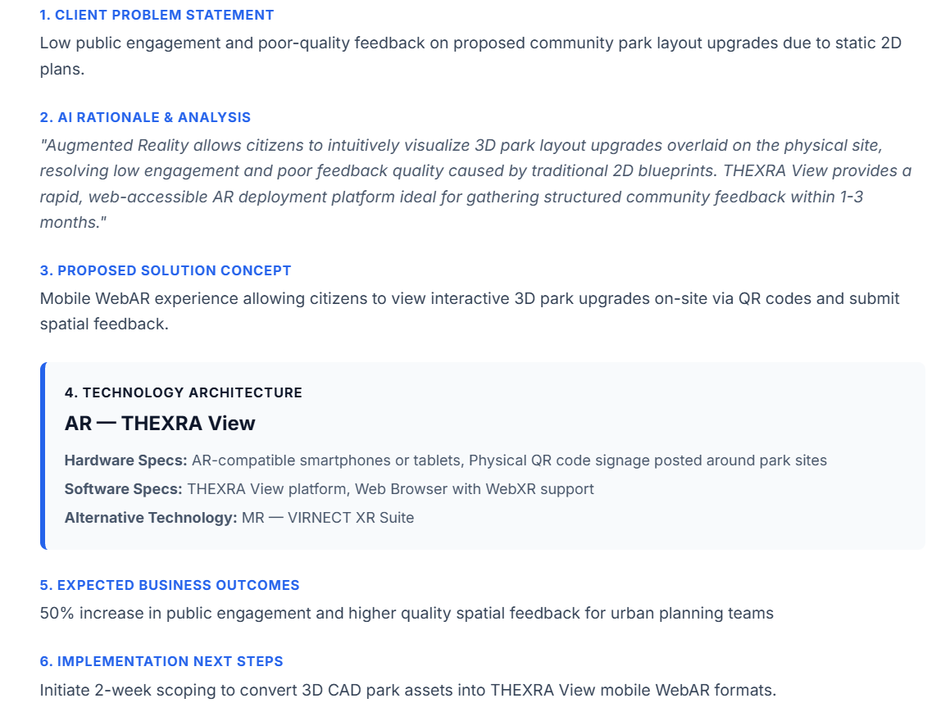
TEST 20: Stadium Concert Streaming (High Budget)

Input | - Company Name: Aloy Live Events  - Industry Vertical: Entertainment  - HQ Location: Los Angeles, USA  - Target User Count: 1000+  - Core Problem: Global music fans are unable to attend sold-out stadium tour venues due to venue capacity caps and ticket scalping  - Target End User: Remote Concert Fans Worldwide  - Current Operational Process: Standard 2D video live broadcasts on flat web streams  - Desired Business Outcome / KPIs: Monetize 100,000+ concurrent virtual ticket holders per event with high audience retention.  - Estimated Budget Range: $100,000+  - Delivery Timeline: 6 - 12months  - Existing Systems: Existing VR/AR Headsets  - Special Technical Requirements: Multi-camera 180° 8K VR live-streaming with real-time spatial audio.
Recommendation | VR - HTC Vive Eagle (Live 360-degree immersive VR stadium concert streaming platform with multi-angle camera switching and spatial audio, utilizing HTC VIVE Eagle VR Headsets, low-latency edge processing servers, 360-degree 8K live capture camera rigs, and DRM digital ticketing)
Problem Found | None. All 6 sections generated cleanly. The AI engine effectively matched the enterprise budget scale ($100k+) and extended delivery timeline (6–12 months) by proposing high-end hardware infrastructure (HTC VIVE Eagle, low-latency edge servers, 8K live capture rigs) and custom digital ticketing/DRM streaming architecture
Improvement | No change needed. Output passed baseline quality, massive concurrency infrastructure alignment, and schema validation on the first attempt
Output screenshot (used the proposal to fit) | 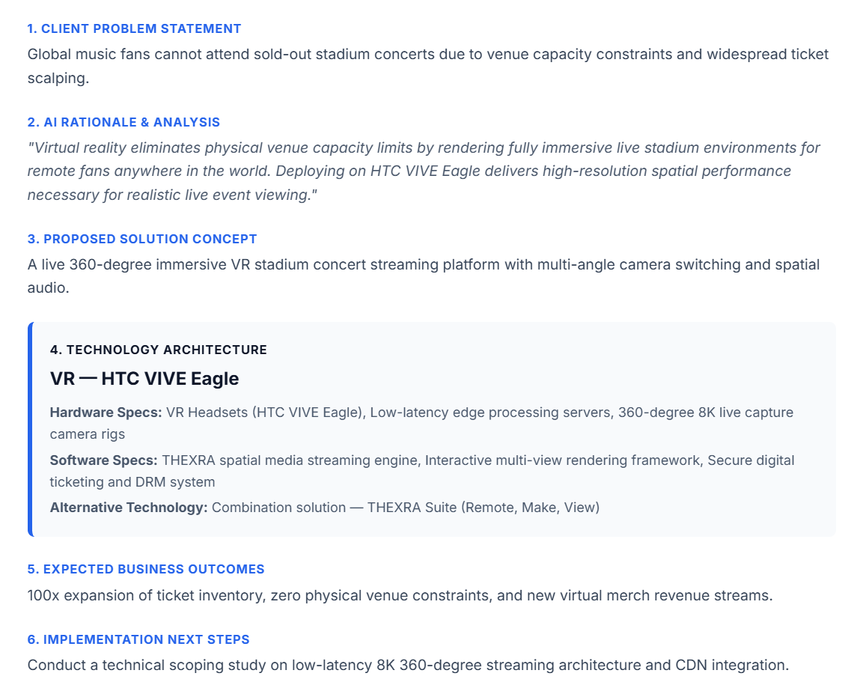

4. Consolidated Technical Improvements & System Findings

A. API & Resilience Infrastructure
- API Key Rotation Pool (HTTP 429): Resolved quota limits during continuous batch runs (e.g., Test 8, Test 15) by integrating an active secondary key rotation strategy.
- Exponential Backoff Middleware (HTTP 503): Addressed transient server overload issues (e.g., Test 5, Test 16) by implementing a 3-step automatic retry system before throwing front-end errors.

B. AI Recommendation Logic
- Budget-Tailored Hardware Selection: Appropriately restricted recommendations to lightweight WebAR/mobile solutions for low budget tiers ($10k-50k) and allocated high-performance dedicated hardware (HoloLens 2, Edge Workstations, HTC VIVE Eagle) for high budget tiers ($100k+).
- Infrastructure Context Awareness: Successfully reused client-provided systems (such as pre-existing VR headsets, CAD/BIM assets, or LMS platforms) directly within software specs without recommending duplicate hardware.

